MACHINE PROBLEM

PYTHON SOLUTION PROBLEM # 5

Aguinaldo, Kurt 2ECE – A

Sales, Ace Lawrence

**SCRIPT FILE:**

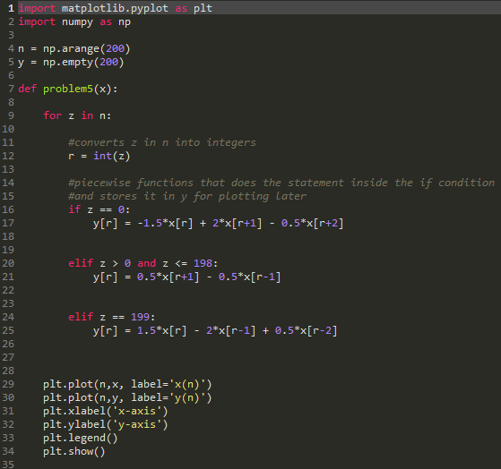

Using input problem4(10,15,45,20,-10)

**OUTPUT:**

